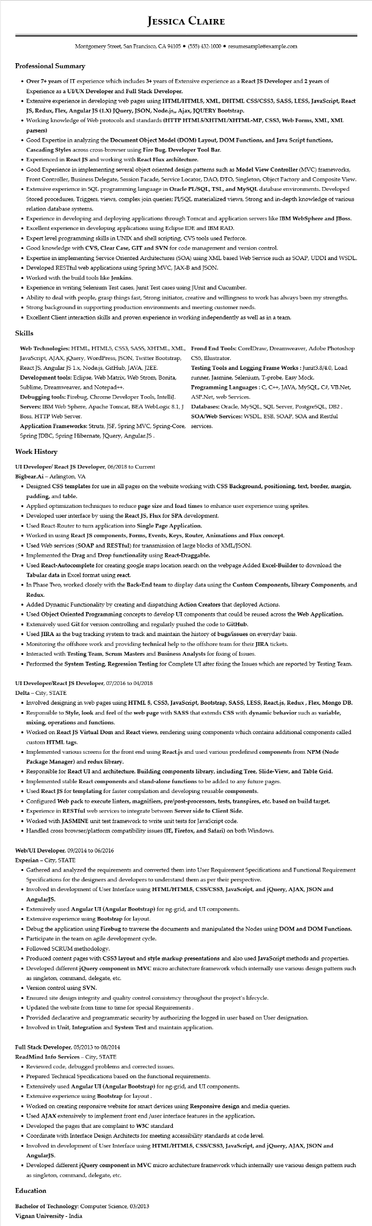
JESSICA CLAIRE
Montgomery Street, San Francisco, CA 94105 ⚫ (555) 432-1000⚫ resumesample@example.com
Professional Summary
• Over 7+ years of IT experience which includes 3+ years of Extensive experience as a React JS Developer and 2 years of Experience as a UI/UX Developer and Full Stack Developer.
• Extensive experience in developing web pages using HTML/HTML5, XML, DHTML CSS/CSS3, SASS, LESS, JavaScript, React JS, Redux, Flex, Angular JS (1.X) JQuery, JSON, Node.js,, Ajax, JQUERY Bootstrap.
• Working knowledge of Web protocols and standards (HTTP HTML5/XHTML/XHTML-MP, CSS3, Web Forms, XML, XML parsers)
• Good Expertise in analyzing the Document Object Model (DOM) Layout, DOM Functions, and Java Script functions, Cascading Styles across cross-browser using Fire Bug, Developer Tool Bar.
• Experienced in React JS and working with React Flux architecture.
• Good Experience in implementing several object oriented design patterns such as Model View Controller (MVC) frameworks, Front Controller, Business Delegate, Session Facade, Service Locator, DAO, DTO, Singleton, Object Factory and Composite View. • Extensive experience in SQL programming language in Oracle PL/SQL, TSL, and MySQL database environments. Developed Stored procedures, Triggers, views, complex join queries; PL/SQL materialized views, Strong and in-depth knowledge of various relation database systems.
• Experience in developing and deploying applications through Tomcat and application servers like IBM WebSphere and JBoss.
• Excellent experience in developing applications using Eclipse IDE and IBM RAD.
• Expert level programming skills in UNIX and shell scripting, CVS tools used Perforce.
• Good knowledge with CVS, Clear Case, GIT and SVN for code management and version control.
• Expertise in implementing Service Oriented Architectures (SOA) using XML based Web Service such as SOAP, UDDI and WSDL.
• Developed RESTful web applications using Spring MVC, JAX-B and JSON.
• Worked with the build tools like Jenkins.
• Experience in writing Selenium Test cases, Junit Test cases using JUnit and Cucumber.
• Ability to deal with people, grasp things fast, Strong initiator, creative and willingness to work has always been my strengths.
• Strong background in supporting production environments and meeting customer needs.
• Excellent Client interaction skills and proven experience in working independently as well as in a team.
Skills
Web Technologies: HTML, HTML5, CSS3, SASS, XHTML, XML, JavaScript, AJAX, jQuery, WordPress, JSON, Twitter Bootstrap, React JS, Angular JS 1.x, Node.js, GitHub, JAVA, J2EE. Development tools: Eclipse, Web Matrix, Web Strom, Bonita, Sublime, Dreamweaver, and Notepad++.
Debugging tools: Firebug, Chrome Developer Tools, IntelliJ. Servers: IBM Web Sphere, Apache Tomcat, BEA WebLogic 8.1, J Boss, HTTP Web Server.
Application Frameworks: Struts, JSF, Spring MVC, Spring-Core, Spring JDBC, Spring Hibernate, JQuery, Angular.JS.
Frond End Tools: CorelDraw, Dreamweaver, Adobe Photoshop CS5, Illustrator.
Testing Tools and Logging Frame Works: Junit3.8/4.0, Load runner, Jasmine, Selenium, T-probe, Easy Mock. Programming Languages : C, C++, JAVA, MySQL, C#, VB.Net, ASP.Net, web Services.
Databases: Oracle, MySQL, SQL Server, PostgreSQL, DB2. SOA/Web Services: WSDL, ESB, SOAP, SOA and Restful services.
Work History
UI Developer/React JS Developer, 06/2018 to Current
Bigbear.Ai - Arlington, VA
• Designed CSS templates for use in all pages on the website working with CSS Background, positioning, text, border, margin, padding, and table.
• Applied optimization techniques to reduce page size and load times to enhance user experience using sprites.
• Developed user interface by using the React JS, Flux for SPA development.
• Used React-Router to turn application into Single Page Application.
• Worked in using React JS components, Forms, Events, Keys, Router, Animations and Flux concept.
• Used Web services (SOAP and RESTful) for transmission of large blocks of XML/JSON.
• Implemented the Drag and Drop functionality using React-Draggable.
• Used React-Autocomplete for creating google maps location search on the webpage Added Excel-Builder to download the Tabular data in Excel format using react.
• In Phase Two, worked closely with the Back-End team to display data using the Custom Components, library Components, and Redux.
• Added Dynamic Functionality by creating and dispatching Action Creators that deployed Actions.
• Used Object Oriented Programming concepts to develop UI components that could be reused across the Web Application.
• Extensively used Git for version controlling and regularly pushed the code to GitHub.
• Used JIRA as the bug tracking system to track and maintain the history of bugs/issues on everyday basis.
• Monitoring the offshore work and providing technical help to the offshore team for their JIRA tickets.
• Interacted with Testing Team, Scrum Masters and Business Analysts for fixing of Issues.
• Performed the System Testing, Regression Testing for Complete UI after fixing the Issues which are reported by Testing Team.
UI Developer/React JS Developer, 07/2016 to 04/2018
Delta City, STATE
• Involved designing in web pages using HTML 5, CSS3, JavaScript, Bootstrap, SASS, LESS, React.js, Redux, Flex, Mongo DB. • Responsible to Style, look and feel of the web page with SASS that extends CSS with dynamic behavior such as variable, mixing, operations and functions.
• Worked on React JS Virtual Dom and React views, rendering using components which contains additional components called custom HTML tags.
• Implemented various screens for the front end using React.js and used various predefined components from NPM (Node Package Manager) and redux library.
• Responsible for React UI and architecture. Building components library, including Tree, Slide-View, and Table Grid.
• Implemented stable React components and stand-alone functions to be added to any future pages.
• Used React JS for templating for faster compilation and developing reusable components.
• Configured Web pack to execute linters, magnifiers, pre/post-processors, tests, transpires, etc. based on build target.
• Experience in RESTful web services to integrate between Server side to Client Side.
• Worked with JASMINE unit test framework to write unit tests for JavaScript code.
• Handled cross browser/platform compatibility issues (IE, Firefox, and Safari) on both Windows.
Web/UI Developer, 09/2014 to 06/2016
Experian - City, STATE
• Gathered and analyzed the requirements and converted them into User Requirement Specifications and Functional Requirement Specifications for the designers and developers to understand them as per their perspective.
• Involved in development of User Interface using HTML/HTML5, CSS/CSS3, JavaScript, and jQuery, AJAX, JSON and AngularJS.
• Extensively used Angular UI (Angular Bootstrap) for ng-grid, and UI components.
• Extensive experience using Bootstrap for layout.
• Debug the application using Firebug to traverse the documents and manipulated the Nodes using DOM and DOM Functions.
• Participate in the team on agile development cycle.
• Followed SCRUM methodology.
• Produced content pages with CSS3 layout and style markup presentations and also used JavaScript methods and properties.
• Developed different jQuery component in MVC micro architecture framework which internally use various design pattern such as singleton, command, delegate, etc.
• Version control using SVN.
• Ensured site design integrity and quality control consistency throughout the project's lifecycle.
• Updated the website from time to time for special Requirements.
• Provided declarative and programmatic security by authorizing the logged in user based on User designation.
• Involved in Unit, Integration and System Test and maintain application.
Full Stack Developer, 05/2013 to 08/2014
ReadMind Info Services - City, STATE
• Reviewed code, debugged problems and corrected issues.
• Prepared Technical Specifications based on the functional requirements.
• Extensively used Angular UI (Angular Bootstrap) for ng-grid, and UI components.
• Extensive experience using Bootstrap for layout.
• Worked on creating responsive website for smart devices using Responsive design and media queries.
• Used AJAX extensively to implement front end /user interface features in the application.
• Developed the pages that are complaint to W3C standard
• Coordinate with Interface Design Architects for meeting accessibility standards at code level.
• Involved in development of User Interface using HTML/HTML5, CSS/CSS3, JavaScript, and jQuery, AJAX, JSON and
AngularJS.
• Developed different jQuery component in MVC micro architecture framework which internally use various design pattern such
as singleton, command, delegate, etc.
Education
Bachelor of Technology: Computer Science, 03/2013
Vignan University - India

